**Phase -2 instructions**

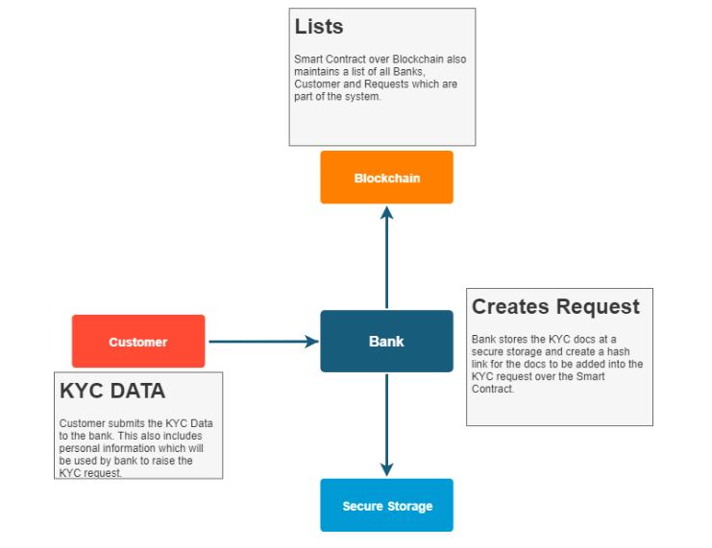

|  |  |
| --- | --- |
| No. | functionalities |
| 1 | Add Bank |
| 2 | Remove Bank |
| 3 | Add customer |
| 4 | Modify customer |
| 5 | Add request |
| 6 | Remove request |
| 7 | Up Vote Customer |
| 8 | Down Vote customer |
| 9 | Bank Report |
| 10 | Bank Allowed to Vote |
| 11 | Get Bank Details |
| 12 | Get Bank Complain |

Admin - 0x5B38Da6a701c568545dCfcB03FcB875f56beddC4

Bank:

Bank1 - 0xaffda618d710165203670274349cef5d7422f194

Bank2 - 0x73d56582460d4fe7b5e8ca4625b29db3adc106b6

Bank3 - 0x7741bbf302113da069f604b06f1fc70322b25345

Bank4 - 0x5d8056d8342d8a7d3f9711fd0f9864ebdfb10651

Bank5 - 0xee9d22bd68d9fcb8c0e37eb482e22616016db30d

Customer:

Cus1 - 0xacaecfc80b842043f3e91267385f544e3f60a586

Cus2 - 0x8703f892785ba355a9cc89f07220b3a6da23b1a9

Cus3 - 0xeb75a6a70719d35e5377469c845d77b3ae634e33

Cus5 - 0x5a83d0ce4497be82f330412362781d6f755cf90b

Admin - 0x5B38Da6a701c568545dCfcB03FcB875f56beddC4

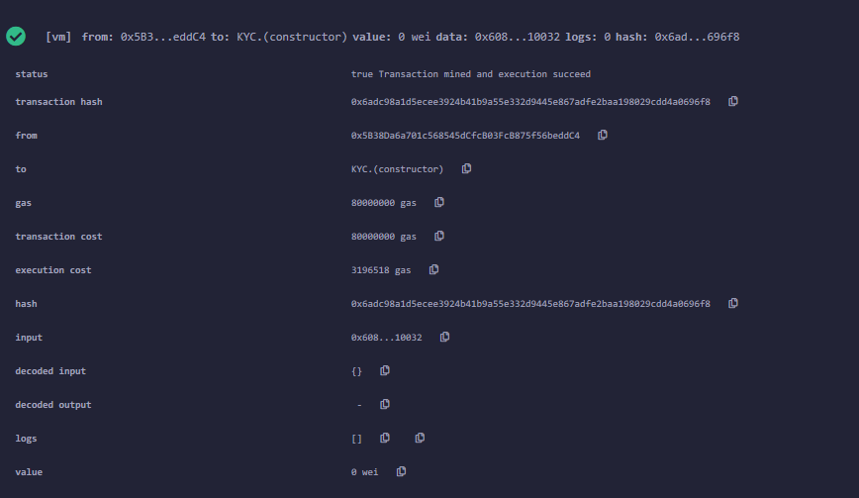

**1.Add Bank:**

Bank1 - 0xaffda618d710165203670274349cef5d7422f194

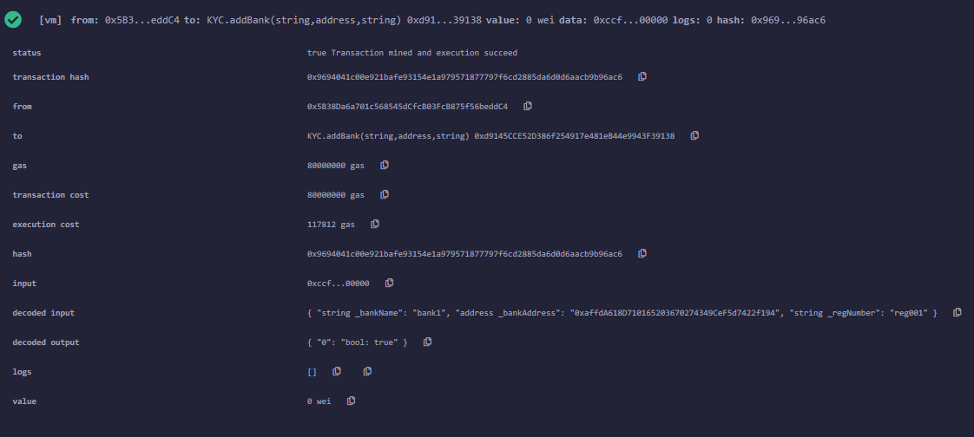

Bank2 - 0x73d56582460d4fe7b5e8ca4625b29db3adc106b6

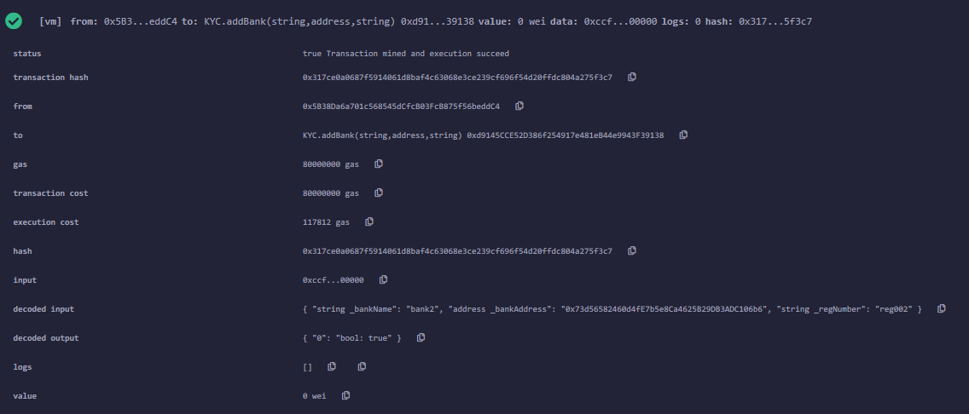

Bank3 - 0x7741bbf302113da069f604b06f1fc70322b25345

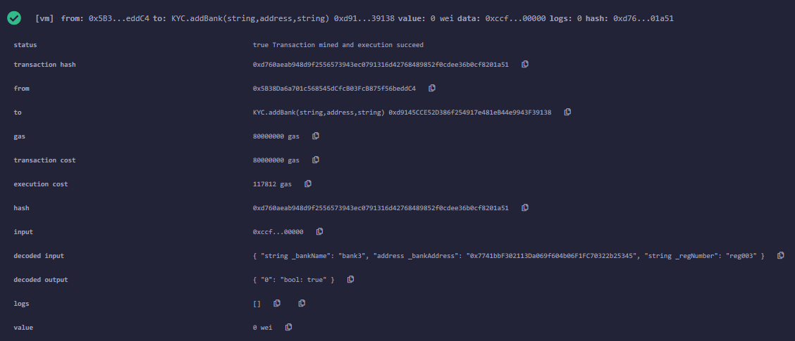

Bank4 - 0x5d8056d8342d8a7d3f9711fd0f9864ebdfb10651

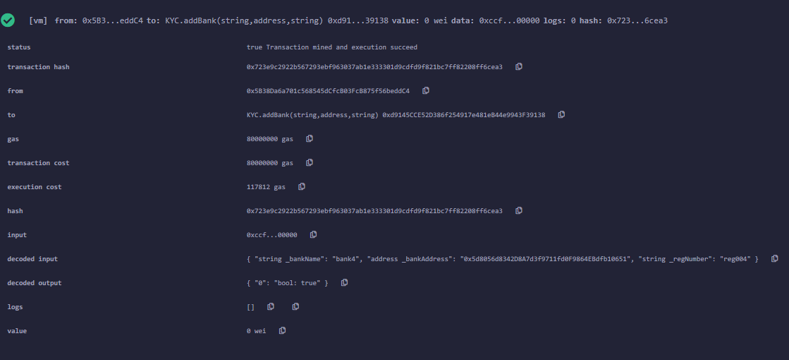

Bank5 - 0xee9d22bd68d9fcb8c0e37eb482e22616016db30d

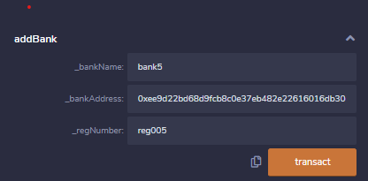

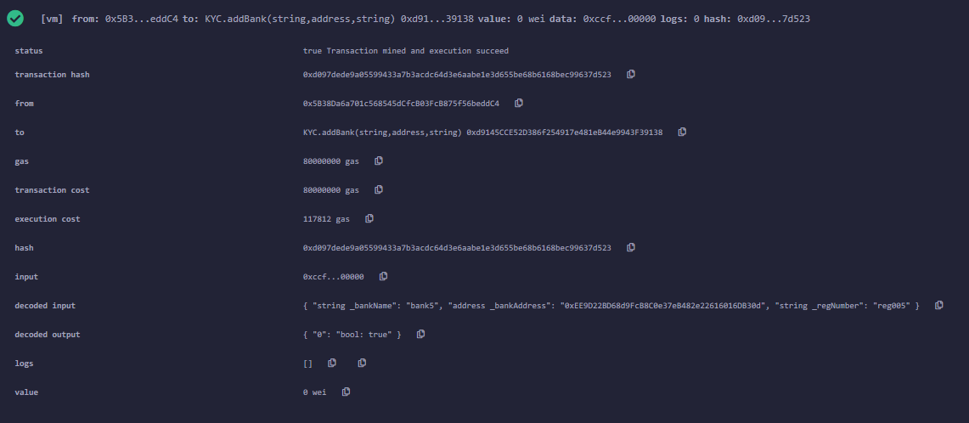

**2.Remove Bank**

Bank4 - 0x5d8056d8342d8a7d3f9711fd0f9864ebdfb10651

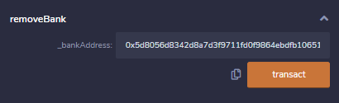

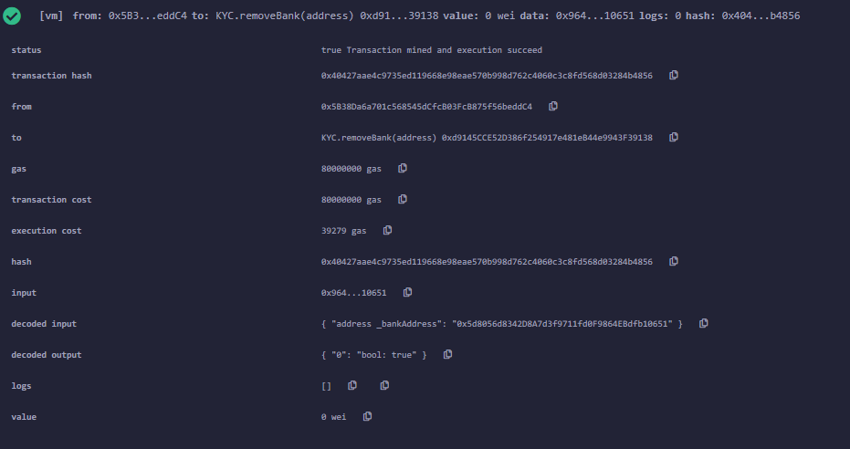

**3.Add Customer**

Bank1 - 0xaffda618d710165203670274349cef5d7422f194

Cus1 -0xacaecfc80b842043f3e91267385f544e3f60a586

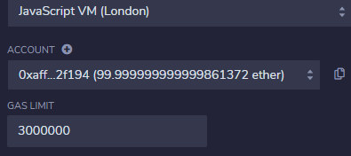

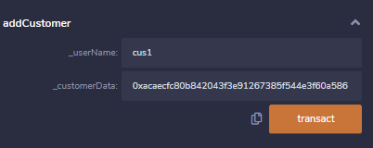

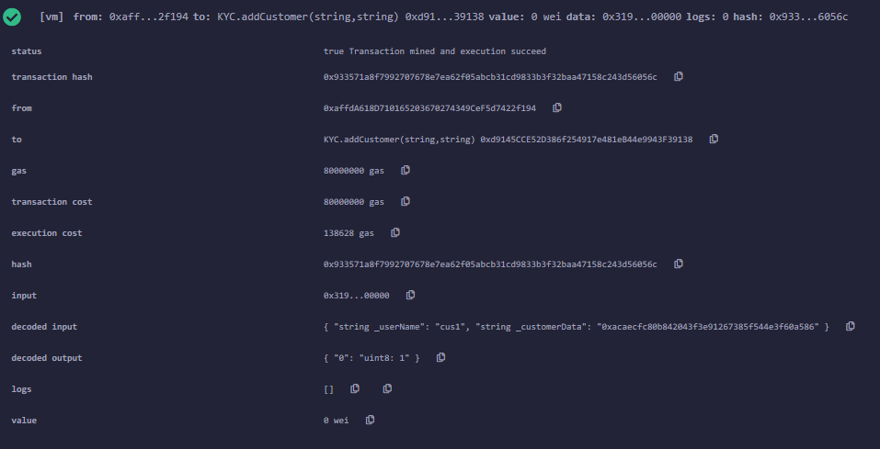

Bank2 - 0x73d56582460d4fe7b5e8ca4625b29db3adc106b6

Cus2 - 0x8703f892785ba355a9cc89f07220b3a6da23b1a9

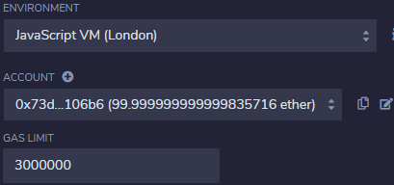

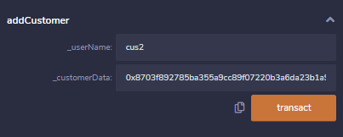

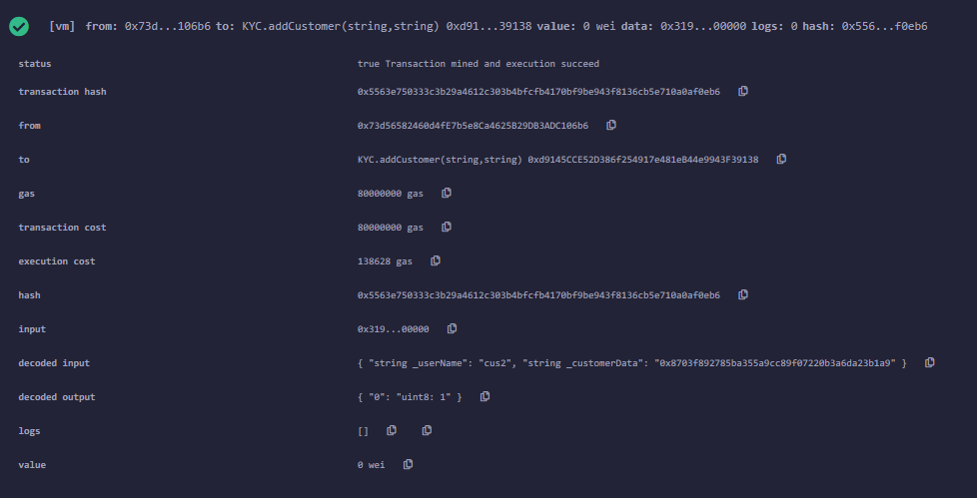

Bank3 - 0x7741bbf302113da069f604b06f1fc70322b25345

Cus3 - 0xeb75a6a70719d35e5377469c845d77b3ae634e33

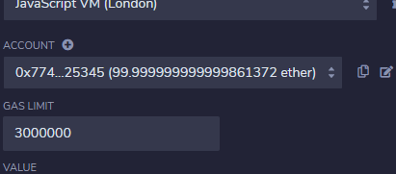

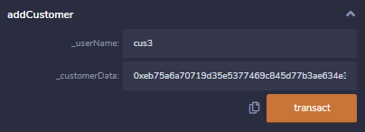

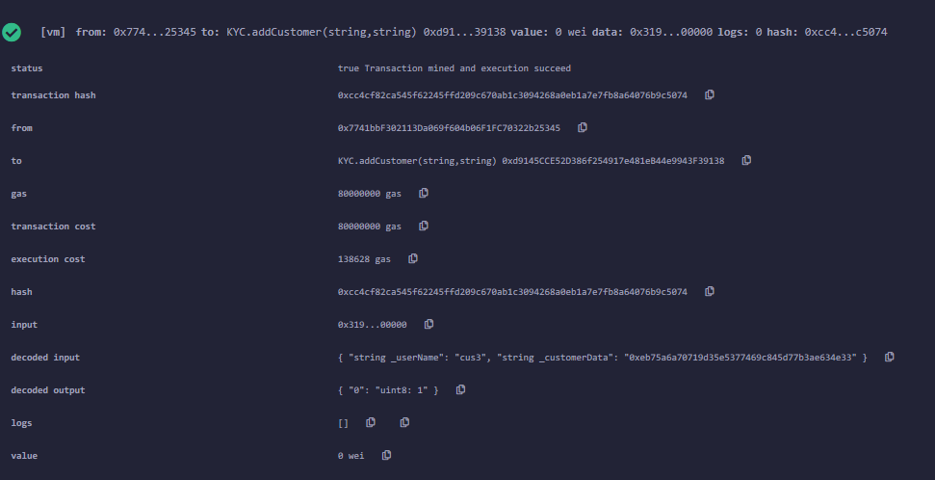

Bank5 - 0xee9d22bd68d9fcb8c0e37eb482e22616016db30d

Cus5 - 0x5a83d0ce4497be82f330412362781d6f755cf90b

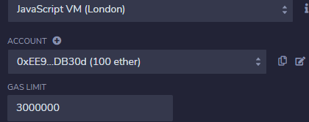

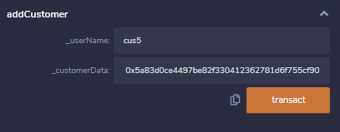

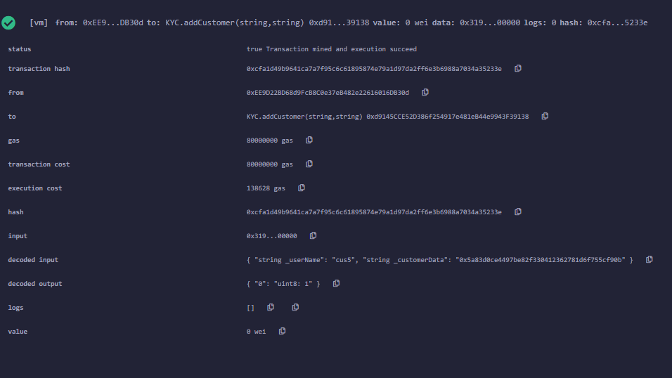

**4.Modify Customer:**

Bank3 - 0x7741bbf302113da069f604b06f1fc70322b25345

Cus3 - 0xeb75a6a70719d35e5377469c845d77b3ae634e33

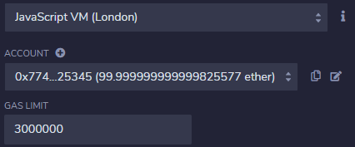

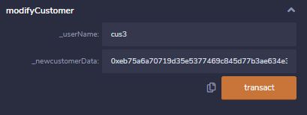

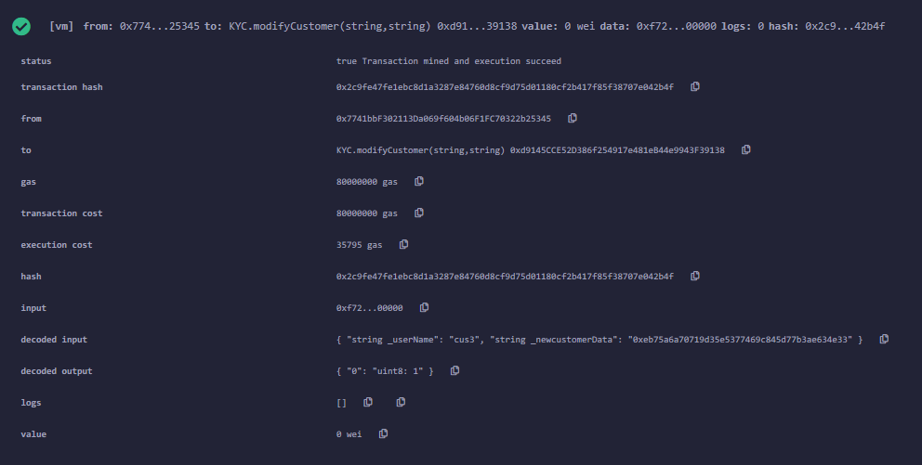

**Add bank by other than Admin – only Admin allowed to add Bank**

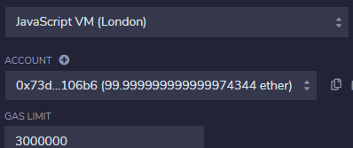

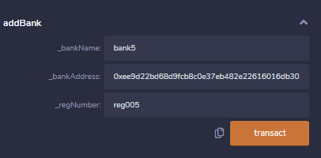

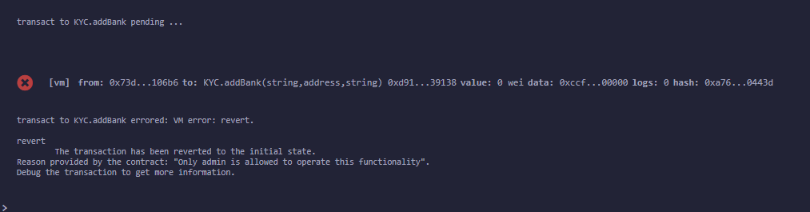

**5.View Customer**

Bank2 - 0x73d56582460d4fe7b5e8ca4625b29db3adc106b6

Cus2 - 0x8703f892785ba355a9cc89f07220b3a6da23b1a9

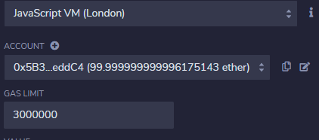

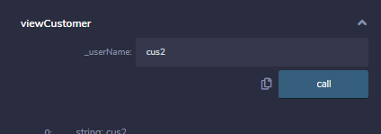

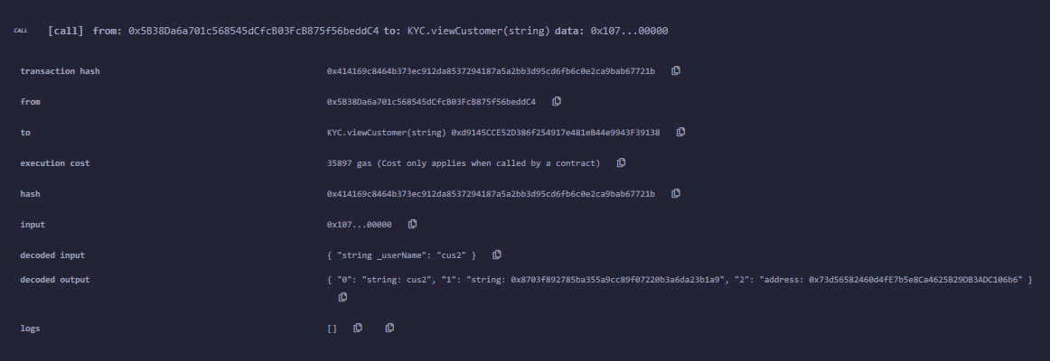

**6.Add Request**

Bank1 - 0xaffda618d710165203670274349cef5d7422f194

Cus1 -0xacaecfc80b842043f3e91267385f544e3f60a586

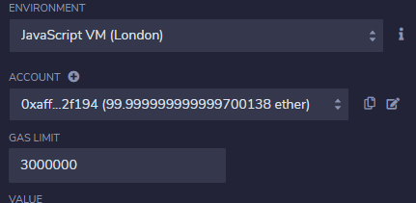

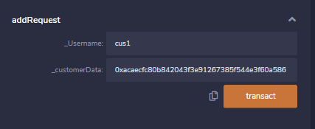

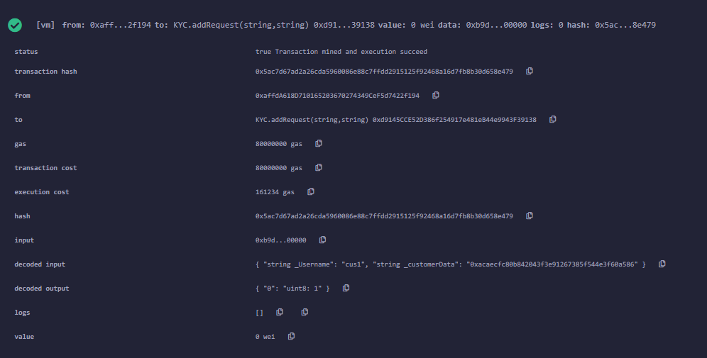

Bank5 - 0xee9d22bd68d9fcb8c0e37eb482e22616016db30d

Cus5 - 0x5a83d0ce4497be82f330412362781d6f755cf90b

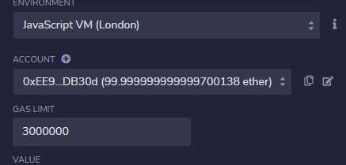

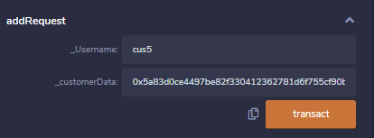

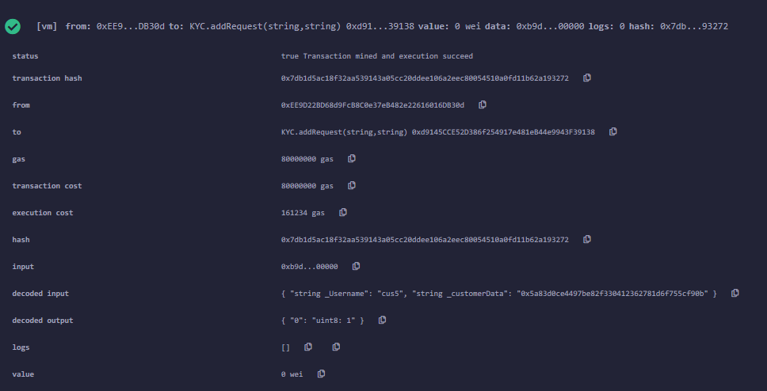

**7.Remove Request**

Bank5 - 0xee9d22bd68d9fcb8c0e37eb482e22616016db30d

Cus5 - 0x5a83d0ce4497be82f330412362781d6f755cf90b

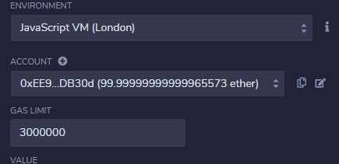

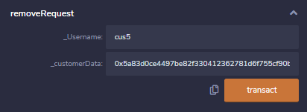

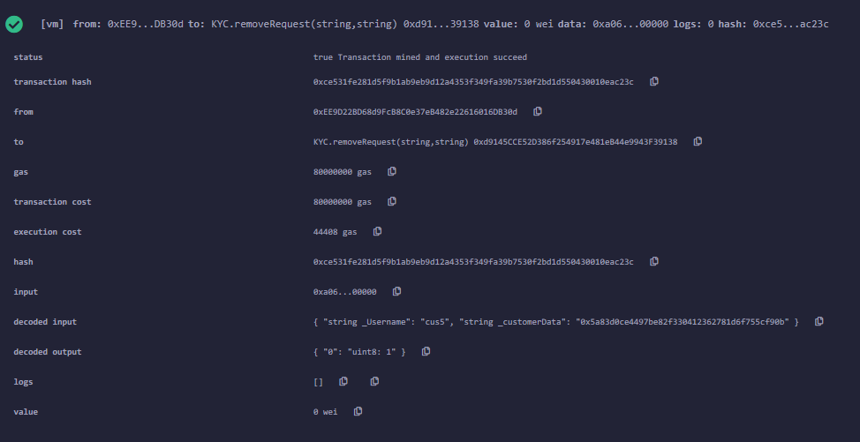

**8.Up Vote Customer**

Bank2 - 0x73d56582460d4fe7b5e8ca4625b29db3adc106b6

Cus2 - 0x8703f892785ba355a9cc89f07220b3a6da23b1a9

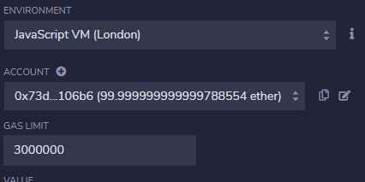



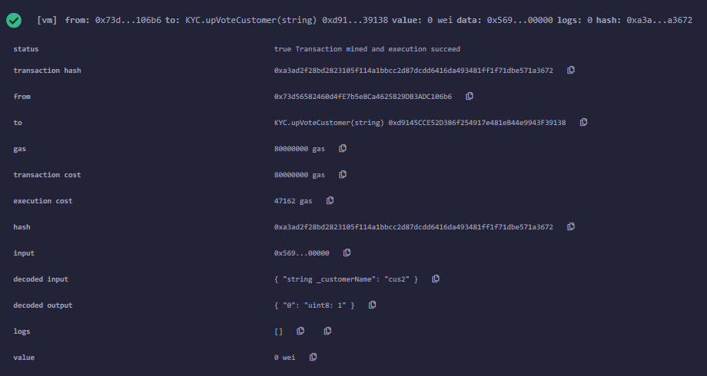

Bank1 - 0xaffda618d710165203670274349cef5d7422f194

Cus1 -0xacaecfc80b842043f3e91267385f544e3f60a586

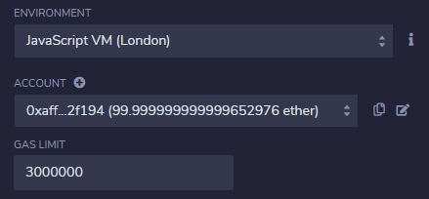



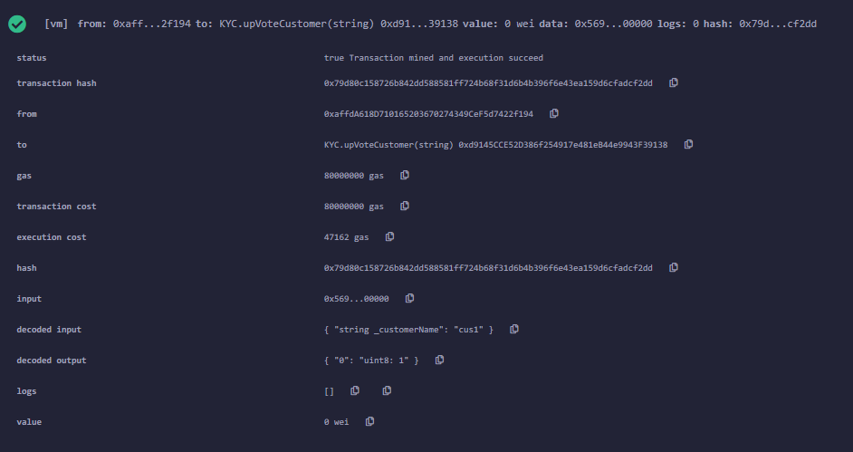

**9.Down Vote Customer**

Bank1 - 0xaffda618d710165203670274349cef5d7422f194

Cus1 -0xacaecfc80b842043f3e91267385f544e3f60a586

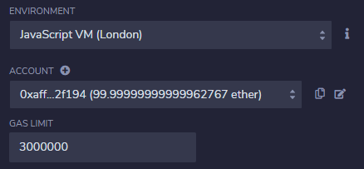

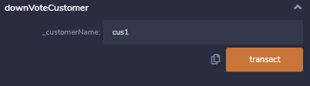

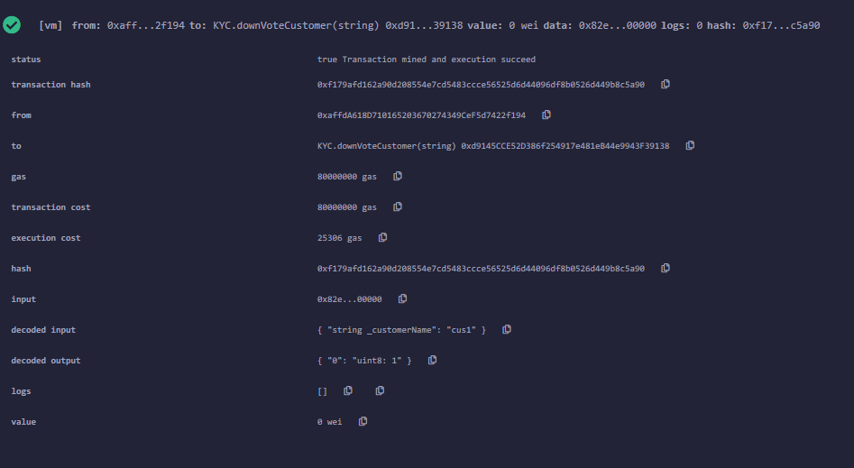

**10.Bank Report**

Bank1 report on Bank2

Bank1 - 0xaffda618d710165203670274349cef5d7422f194

Bank2 - 0x73d56582460d4fe7b5e8ca4625b29db3adc106b6

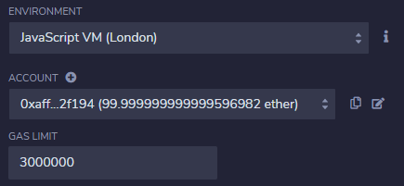

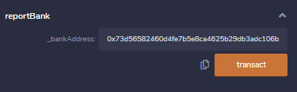

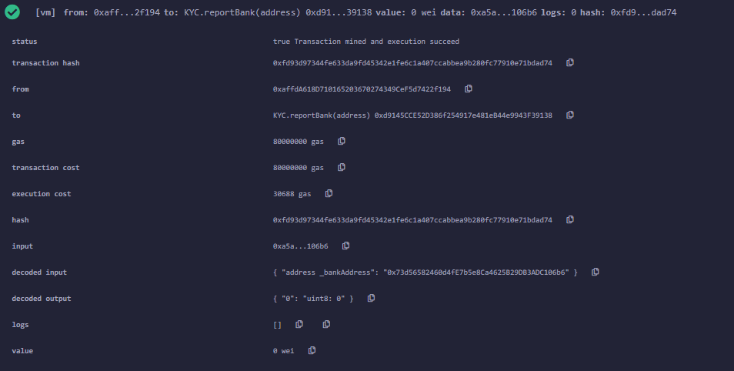

**11.Bank Allowed To Vote**

Bank2 - 0x73d56582460d4fe7b5e8ca4625b29db3adc106b6

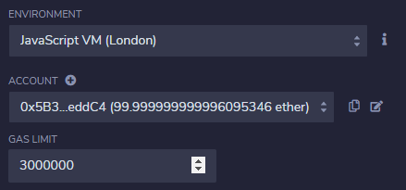

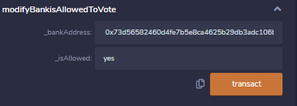

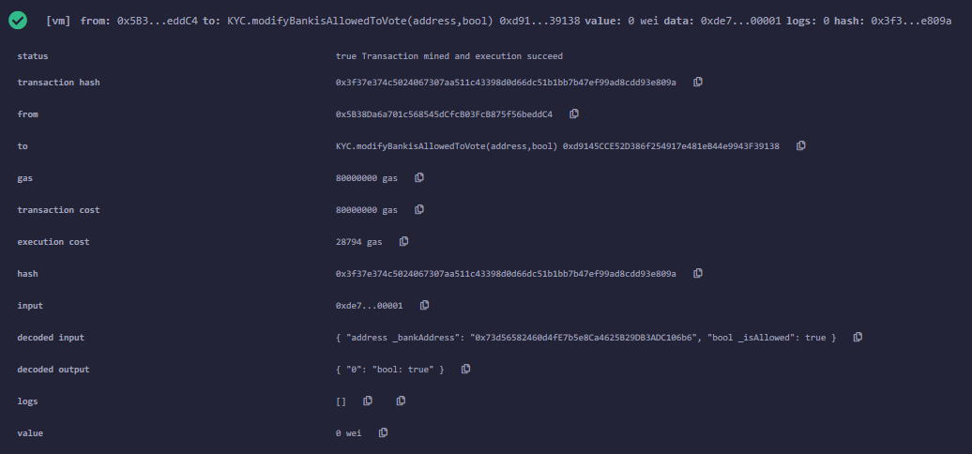

**12.Get Bank Details:**

Bank3 - 0x7741bbf302113da069f604b06f1fc70322b25345

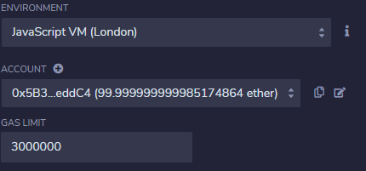

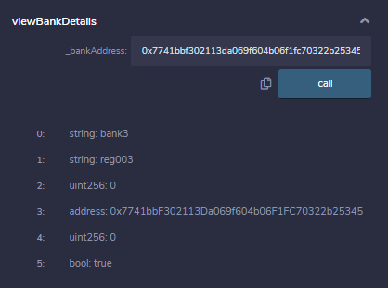

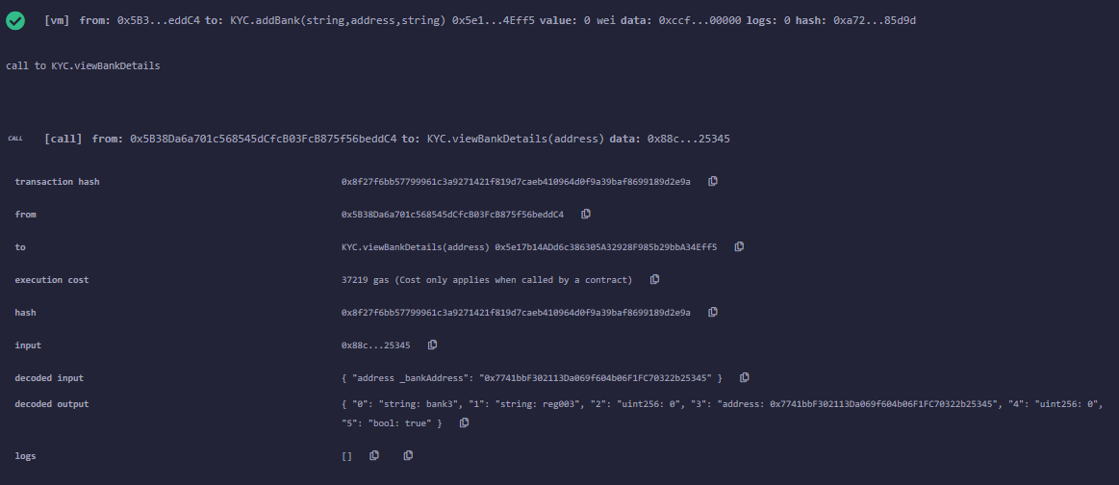

**13.Get Bank complain:**

Bank1 checking complaint on Bank3

Bank1 - 0xaffda618d710165203670274349cef5d7422f194

Bank3 - 0x7741bbf302113da069f604b06f1fc70322b25345

